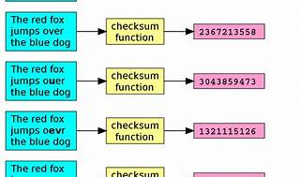

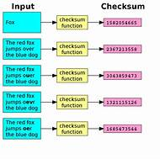

Explore

Certainly! **Checksum** is an error detection method used by upper layer protocols to verify data integrity during transmission. It involves a **Checksum Generator** on the sender side and a **Checksum Checker** on the receiver side. The sender computes a checksum for the data, which is appended to the original data unit and transmitted. The receiver performs the same computation and checks if the received checksum matches the computed one. [If they match, the data is considered error-free1](https://www.geeksforgeeks.org/error-detection-code-checksum/).

Here are **five free reference links** where you can learn more about checksums:

1. **GeeksforGeeks**[: Provides detailed explanations and examples of checksums in programming and networkingLink1](https://www.geeksforgeeks.org/error-detection-code-checksum/).
2. **C/C++ program to implement CHECKSUM**[: A practical example of implementing checksums in C/C++](https://www.geeksforgeeks.org/error-detection-code-checksum/)[Link2](https://www.geeksforgeeks.org/c-c-program-to-implement-checksum/).
3. **Wikipedia**[: A concise overview of checksums and their role in detecting errors during data transmission or storage](https://www.geeksforgeeks.org/error-detection-code-checksum/)[Link3](https://en.wikipedia.org/wiki/Checksum).
4. **Meal Delivery Reviews**: Covers the basics of checksums and their application. Link.
5. **AMERICAN GARDENER**: Briefly explains the concept of checksums. Link.

Feel free to explore these resources to deepen your understanding of checksums! 🚀